**DIRECTORY TREE STRUCTURE**

**EXPT NO: 2 DATE: 7/9/2022**

**AIM**

To create a tree structure using Directories/Files with help of various Linux Commands.

**THEORY**

Various commands we used are:

1. ls- list all files and directories in current working directory.

2. cat>>filename- create new file with specified name.

    cat filename- displays content of file.

3. cd- used to go back to root directory.

      cd ..- use to change directory to go back one folder.

4. mkdir foldername- to create a directory.

5. rmdir foldername- to delete a directory. (to delete directory, it should be empty first)

6. rm filename- delete file.

7. tree foldername- to show all tree like structure formed using all the folders/files and subfolders/subfiles within it.

**Problem Statement:**

To create a directory tree structure shown below using various Linux commands:

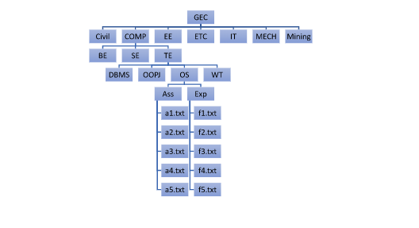

**OUTPUT**

**lloyd@LLOYD:~$ cd Desktop**

**-bash: cd: Desktop: No such file or directory**

**lloyd@LLOYD:~$ cd /mnt/c/Users/lloyd/Desktop**

**lloyd@LLOYD:/mnt/c/Users/lloyd/Desktop$ mkdir GEC**

**lloyd@LLOYD:/mnt/c/Users/lloyd/Desktop$ cd GEC**

**lloyd@LLOYD:/mnt/c/Users/lloyd/Desktop/GEC$ mkdir CIVIL**

**lloyd@LLOYD:/mnt/c/Users/lloyd/Desktop/GEC$ mkdir COMP**

**lloyd@LLOYD:/mnt/c/Users/lloyd/Desktop/GEC$ mkdir EnE**

**lloyd@LLOYD:/mnt/c/Users/lloyd/Desktop/GEC$ mkdir ETC**

**lloyd@LLOYD:/mnt/c/Users/lloyd/Desktop/GEC$ mkdir IT**

**lloyd@LLOYD:/mnt/c/Users/lloyd/Desktop/GEC$ mkdir MECH**

**lloyd@LLOYD:/mnt/c/Users/lloyd/Desktop/GEC$ mkdir MINING**

**lloyd@LLOYD:/mnt/c/Users/lloyd/Desktop/GEC$ cd COMP**

**lloyd@LLOYD:/mnt/c/Users/lloyd/Desktop/GEC/COMP$ mkdir BE**

**lloyd@LLOYD:/mnt/c/Users/lloyd/Desktop/GEC/COMP$ mkdir SE**

**lloyd@LLOYD:/mnt/c/Users/lloyd/Desktop/GEC/COMP$ mkdir TE**

**lloyd@LLOYD:/mnt/c/Users/lloyd/Desktop/GEC/COMP$ cd TE**

**lloyd@LLOYD:/mnt/c/Users/lloyd/Desktop/GEC/COMP/TE$ mkdir DBMS**

**lloyd@LLOYD:/mnt/c/Users/lloyd/Desktop/GEC/COMP/TE$ mkdir OOPJ**

**lloyd@LLOYD:/mnt/c/Users/lloyd/Desktop/GEC/COMP/TE$ mkdir OS**

**lloyd@LLOYD:/mnt/c/Users/lloyd/Desktop/GEC/COMP/TE$ mkdir WT**

**lloyd@LLOYD:/mnt/c/Users/lloyd/Desktop/GEC/COMP/TE$ cd OS**

**lloyd@LLOYD:/mnt/c/Users/lloyd/Desktop/GEC/COMP/TE/OS$ mkdir ASSIGNMENT**

**lloyd@LLOYD:/mnt/c/Users/lloyd/Desktop/GEC/COMP/TE/OS$ mkdir EXPERIMENT**

**lloyd@LLOYD:/mnt/c/Users/lloyd/Desktop/GEC/COMP/TE/OS$ cd ASSIGNMENT**

**lloyd@LLOYD:/mnt/c/Users/lloyd/Desktop/GEC/COMP/TE/OS/ASSIGNMENT$ CAT a1.txt**

**CAT: command not found**

**lloyd@LLOYD:/mnt/c/Users/lloyd/Desktop/GEC/COMP/TE/OS/ASSIGNMENT$ cat>>a1.txt**

**^Z**

**[1]+ Stopped cat >> a1.txt**

**lloyd@LLOYD:/mnt/c/Users/lloyd/Desktop/GEC/COMP/TE/OS/ASSIGNMENT$ cat>>a2.txt**

**^Z**

**[2]+ Stopped cat >> a2.txt**

**lloyd@LLOYD:/mnt/c/Users/lloyd/Desktop/GEC/COMP/TE/OS/ASSIGNMENT$ cat>>a3.txt**

**^Z**

**[3]+ Stopped cat >> a3.txt**

**lloyd@LLOYD:/mnt/c/Users/lloyd/Desktop/GEC/COMP/TE/OS/ASSIGNMENT$ cat>>a4.txt**

**^Z**

**[4]+ Stopped cat >> a4.txt**

**lloyd@LLOYD:/mnt/c/Users/lloyd/Desktop/GEC/COMP/TE/OS/ASSIGNMENT$ cat>>a5.txt**

**^Z**

**[5]+ Stopped cat >> a5.txt**

**lloyd@LLOYD:/mnt/c/Users/lloyd/Desktop/GEC/COMP/TE/OS/ASSIGNMENT$ cd ..**

**lloyd@LLOYD:/mnt/c/Users/lloyd/Desktop/GEC/COMP/TE/OS$ cd EXPERIMENT**

**lloyd@LLOYD:/mnt/c/Users/lloyd/Desktop/GEC/COMP/TE/OS/EXPERIMENT$ cat>>f1.txt**

**^Z**

**[6]+ Stopped cat >> f1.txt**

**lloyd@LLOYD:/mnt/c/Users/lloyd/Desktop/GEC/COMP/TE/OS/EXPERIMENT$ cat>>f2.txt**

**^Z**

**[7]+ Stopped cat >> f2.txt**

**lloyd@LLOYD:/mnt/c/Users/lloyd/Desktop/GEC/COMP/TE/OS/EXPERIMENT$ cat>>f3.txt**

**^Z**

**[8]+ Stopped cat >> f3.txt**

**lloyd@LLOYD:/mnt/c/Users/lloyd/Desktop/GEC/COMP/TE/OS/EXPERIMENT$ cat>>f4.txt**

**^Z**

**[9]+ Stopped cat >> f4.txt**

**lloyd@LLOYD:/mnt/c/Users/lloyd/Desktop/GEC/COMP/TE/OS/EXPERIMENT$ cat>>f5.txt**

**^Z**

**[10]+ Stopped cat >> f5.txt**

**lloyd@LLOYD:/mnt/c/Users/lloyd/Desktop/GEC/COMP/TE/OS/EXPERIMENT$**

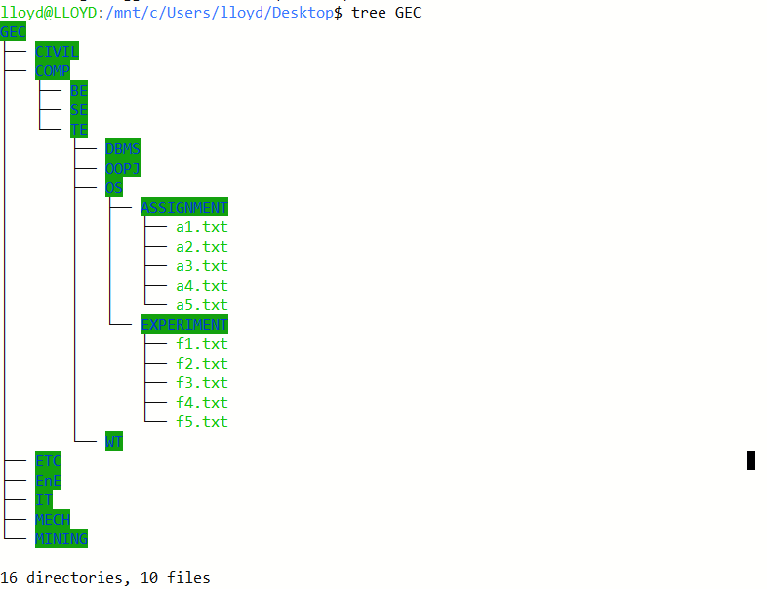

**CONCLUSION**

Various Linux commands were learnt and executed.